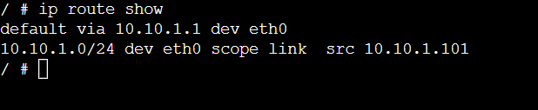
Host 1

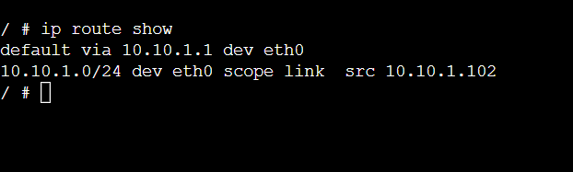
Host 2

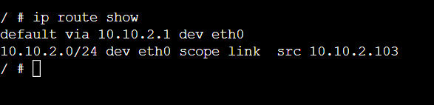
Host 3

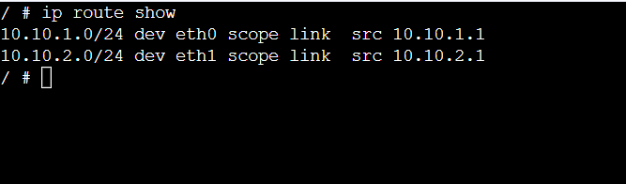
Router

